**Project Description:**

We can divide the project into two parts first the auction part and the automobile management part.

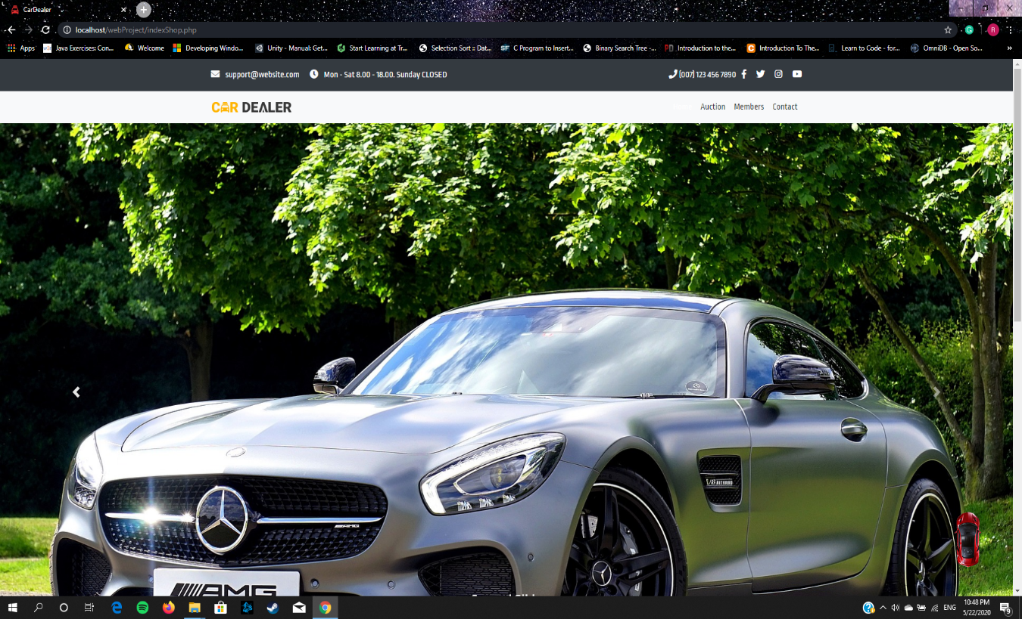

The management system is between salesman and dealers in cars companies.

Admin page can view the data in charts add salesman view customer, dealers, car data.

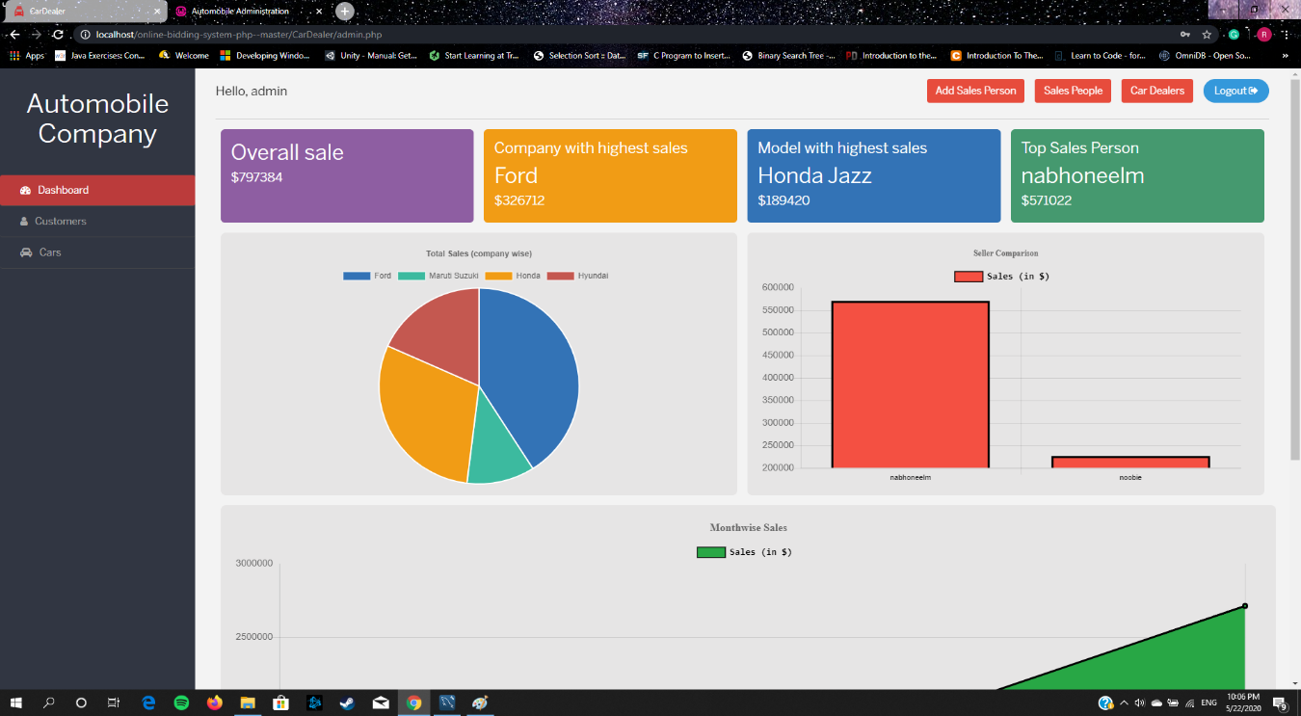

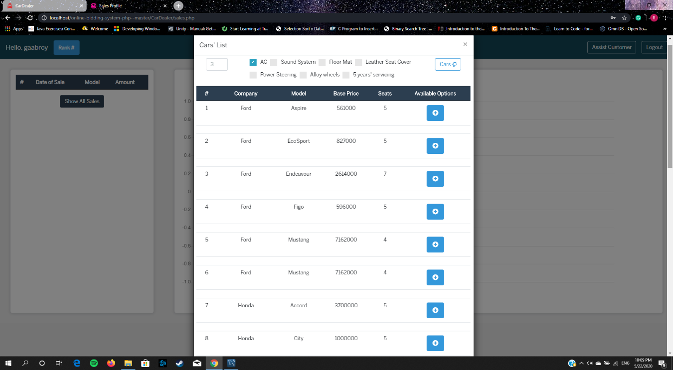

The salesman page that can assists a customer to buy a car.

Generating bills in salesman page to proceed to checkout.

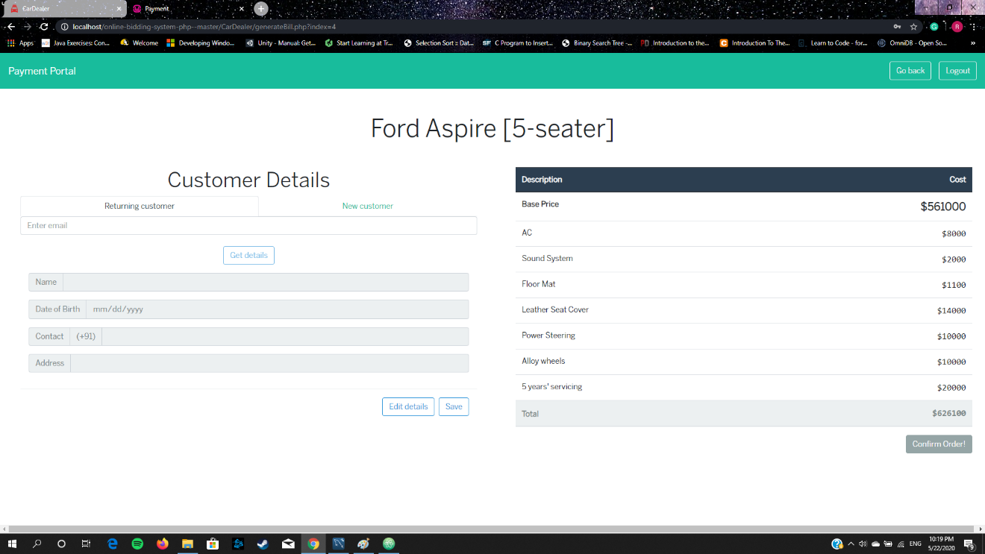

The dealer can add cars info to the system.

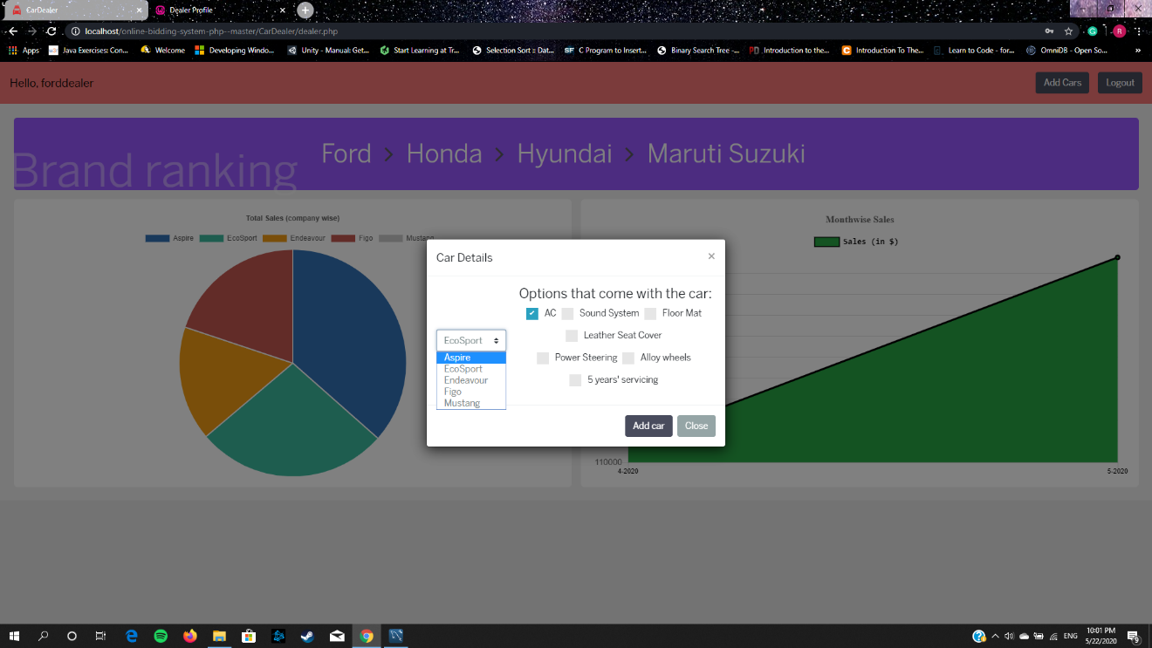

The auction Part:

In the home page you can see the current running auction that you can start bidding after login.

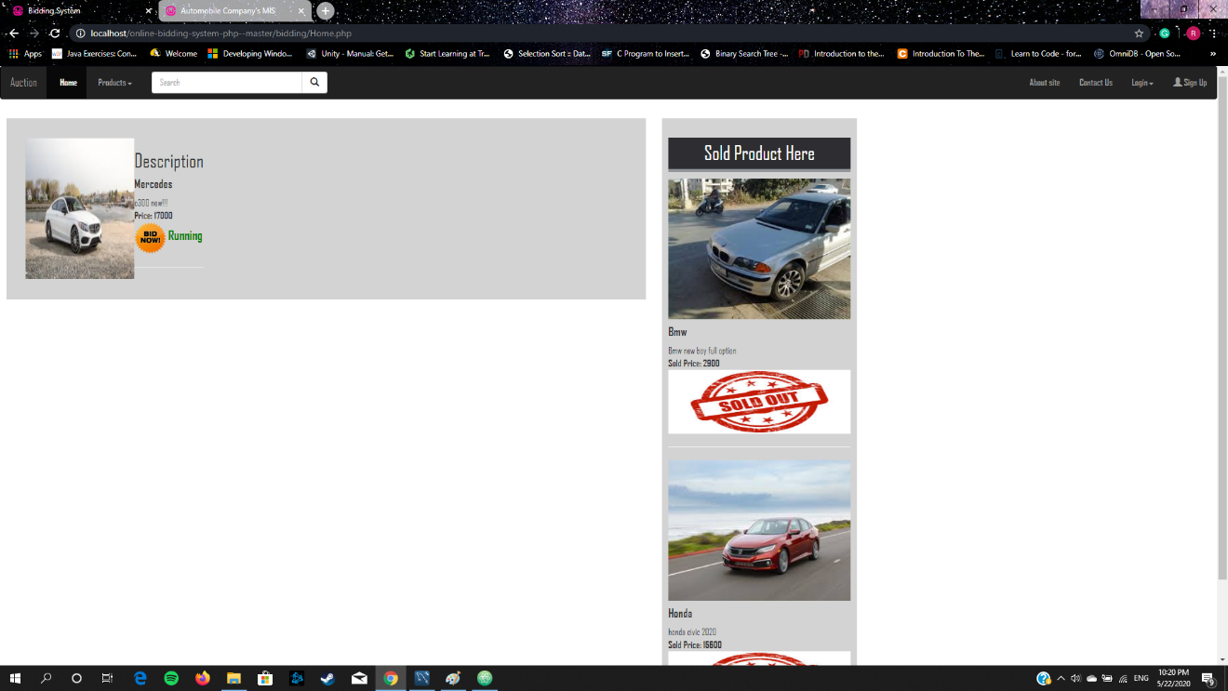

Add a post to let the users to start bidding during specific time.

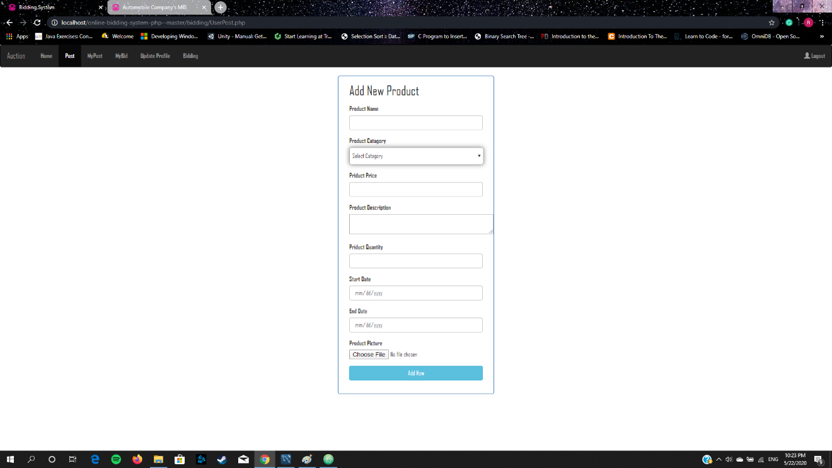

Update your profile.

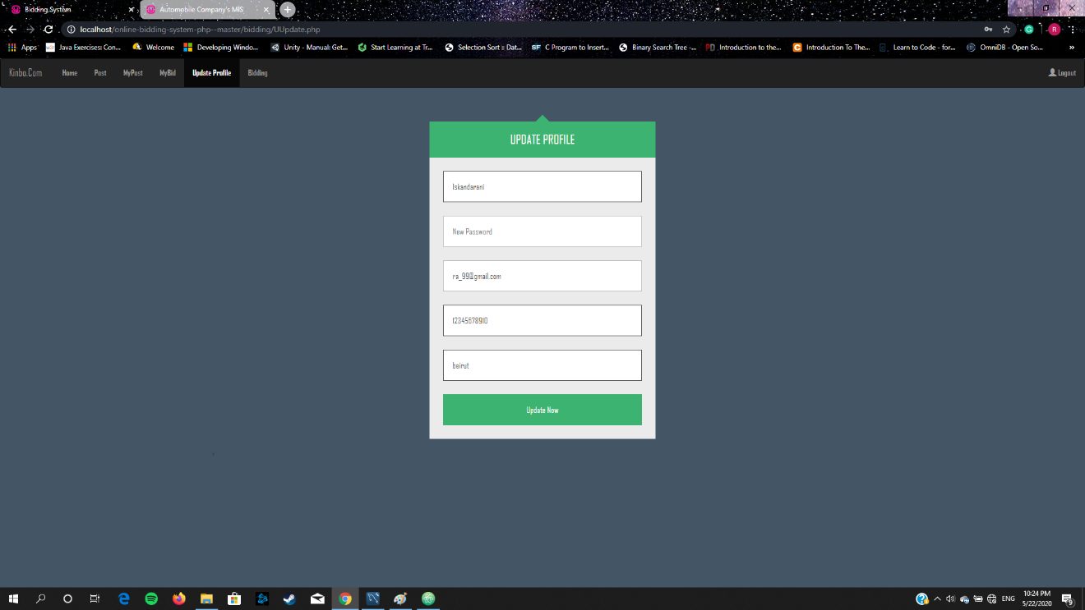

The user can choose his bid.

